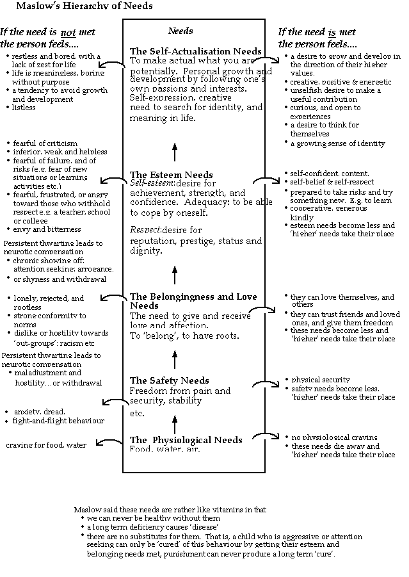

Making use of Maslow’s Hierarchy of Needs to Problem Solve

Defining the Problem
Consider an individual in your class whose behaviour is problematical. Can you type this behaviour as due to a lack of belongingness, esteem, or self-actualisation needs? Or is it a combination of these?

Considering Solutions
What do you do in most classes that satisfies:
Self-actualisation needs?
Self-esteem needs and the need for esteem from others?
Belongingness needs?

Recognising and Devising Some Strategies
Which strategies do you use now to satisfy these needs through college work?

Self-actualisation needs
Work towards personal targets
Express personal values beliefs and priorities
Make choices to control your own development in the direction of your own values
Express yourself, and your values, through accomplishments: creativity, performances, ..
The search for identity and a search for a meaning to one’s life: through work, through making use of your own talents and abilities; from exploration of what interests you…

Esteem needs
Self-esteem:
Achievement, success and confidence, through overcoming challenges and making progress in a direction that your value
recognition of one’s own success
adequacy: to be able to cope by oneself
esteem of others:
respect: a desire for dignity through reputation, prestige, and status
recognition of others of your success, achievement etc

Belongingness and love needs
To give affection and regard to others, to help others
To belong: to my team, class, group, and college
To get affection and recognition from others
To be valued as a person, not just for what I do for others
To be wanted as a person
Which new strategies could you use, and which old ones could you use more often, to satisfy these needs through college work?
Don’t underestimate the power of symbols that show esteem needs, and belongingness needs are being met. For example:
My name being remembered and used positively
A welcome when I come in the class
My work on the classroom wall
A star earned for effort on the classroom wall or on my work
Teacher recognition in the form of competences signed off, comments on work etc
Motivating with Maslow.
We can also consider classes as a whole with Maslow. Indeed his theory could be used to predict the motivating effect of active learning:
Students should be set a challenge which requires a personal response (self actualisation)
e.g. design a poster
develop you own opinions and ideas, along with a full justification on……
Students work in pairs or small groups and their ideas should be valued by that group (belongingness and love needs)
Students should help each other: (belongingness and love needs)
The products made by students as part of their active learning should be valued, there should be an ‘audience’ for them other than the teacher. (esteem needs)
Eg. Displaying the poster in the corridor or on the classroom wall or put on the intranet.
students presenting their ideas to the class and having them valued

